Presentation Report Designer (diagram)

Author: $Author

Publisher: $Publisher

Date: $date
The Presentation Report Designer diagram provides a convenient way to prepare simple structure of Microsoft PowerPoint presentation template (PPTX), as shown in the following steps.

Create your Presentation Report Designer diagram
Create a new Presentation Report Designer diagram in the Report Designer Diagrams category.
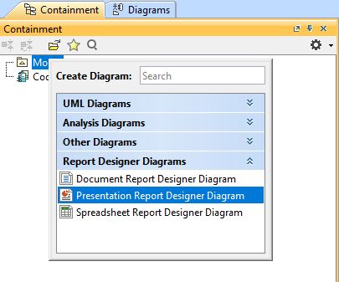
You will get the empty Presentation Report Designer diagram.
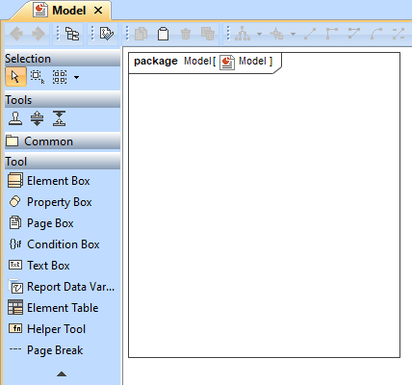

Start with Text Box
Click the Text Box button on the toolbar and drag it to the diagram. Type static text or Velocity code in the box as desired.
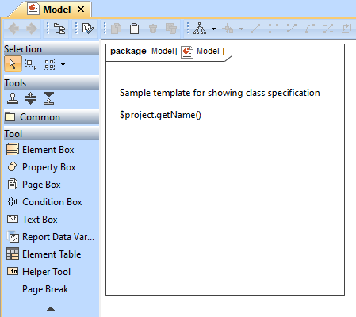

Print Class elements
Click the Element Box button on the toolbar and drag it to the diagram. The Select Element dialog will open. Select the Class element in your project.
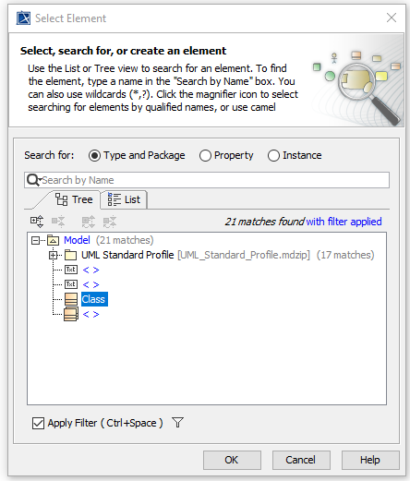

You will get the \#foreach directive for printing all Class elements in your project.

Print Class name and list properties
Create Property Box in Element Box to list properties of Class. Type name in the search box and select it from the list shown up.
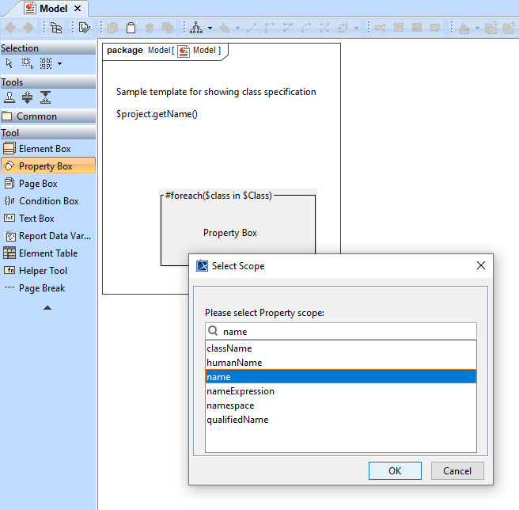
You will get a box for printing the Class name.
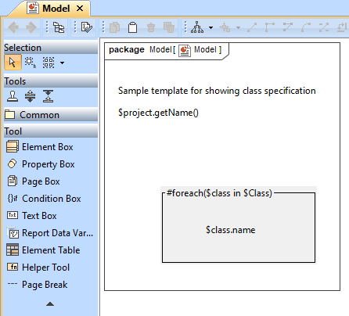

Create another Property Box for the member property returning a collection so that you will get its items in the \#foreach directive.
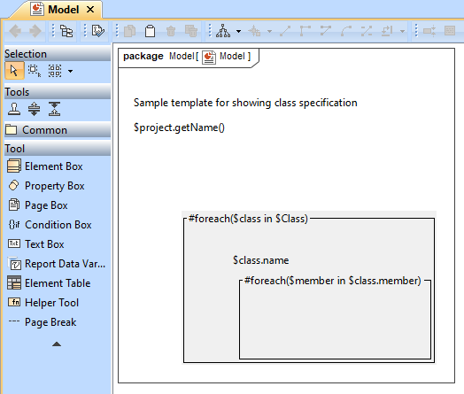

Create static Member: Text Box before the \#foreach directive of \$class.member and create dynamic \$member.name Text Box in the \#foreach directive of \$class.member.
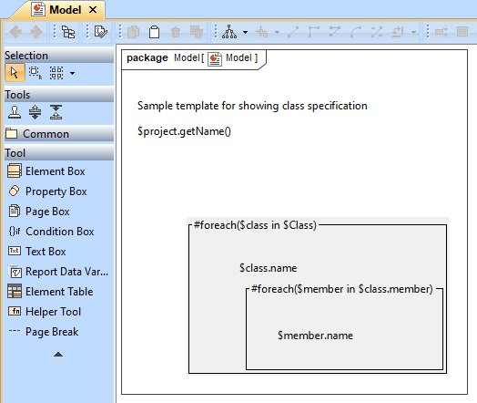
Note: You can create Property Box only in Element Box and Page Box.

Define condition statements
Click the Condition Box button on the toolbar and drag it to the diagram for classifying a Class name.
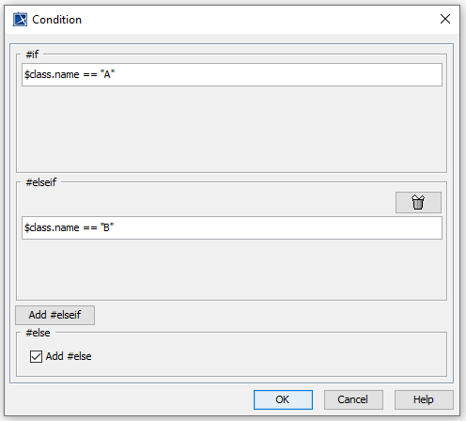
Then, create Text Box for each condition.
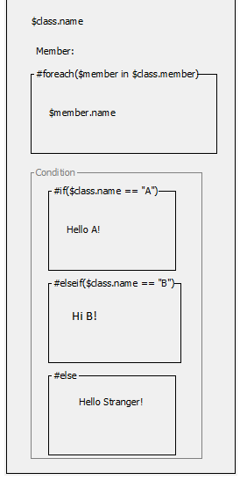

Print value from Report Data Variable
Click the Report Data Variable button on the toolbar and drag it to the diagram to create your Report Data and its Variable. In the open Report Data Variable dialog, select Report Data and Variable, e.g., author.
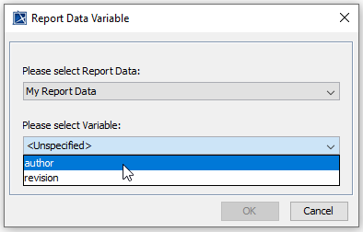
The \$author variable will be created. You can add more text before the Variable name, e.g., Created By: \$author.
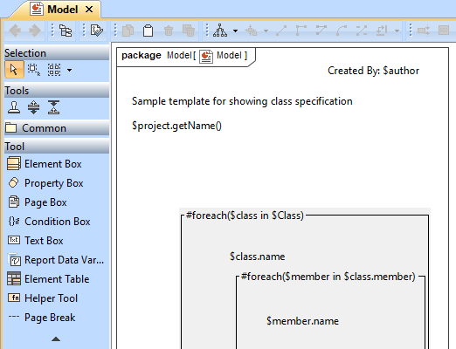

Create a link
You can create a link by using the Helper Tool element where you can find more utilized functions. Click the Helper Tool button on the toolbar and drag it to the diagram to create it. In the open Helper Tool dialog, select Create hyperlink by specifying URL.

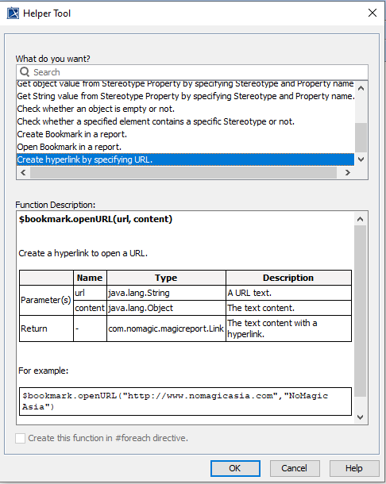

You will have the parameters in \$bookmark.openURL(url, content) updated to \$bookmark.openURL(“www.nomagic.com”,“NoMagic”).

Add Page Break after the first template segment
You can start a new page by adding the Page Break element. Click the Page Break button on the toolbar and drag it to the diagram to create it.
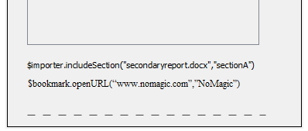

Print a new segment starting with a new page
You can start a new page for every element in a collection by using the \#forpage directive created in Page Box as well as Element Box.
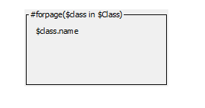

Print Element in a table
You can list all elements in a table by using Element Table. Click the Element Table button on the toolbar and drag it to the diagram to create it. Each element will be printed in a row using the \#forrow directive.
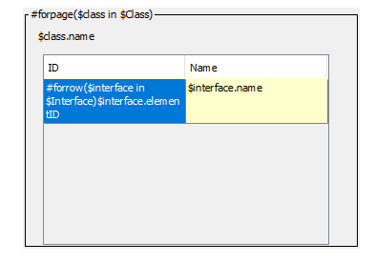

Generate PPTX template from the Presentation Report Designer diagram

Here is the complete Presentation Report Designer diagram.
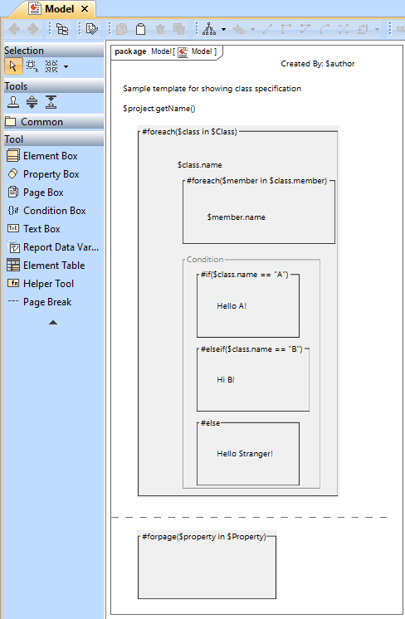

You can start to generate the template by right-clicking Presentation Report Designer in the Containment tree and selecting Generate Template > PPTX Template.
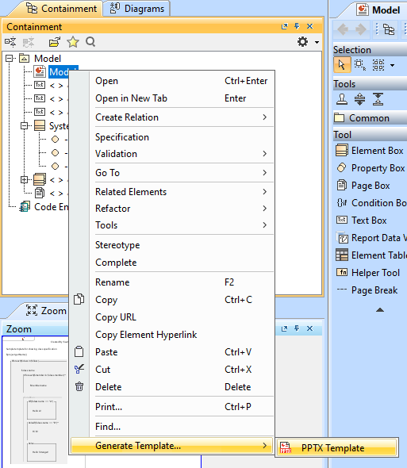

Here is the complete template you can refine more code logic and apply font styles in Microsoft PowerPoint.
Page 1:

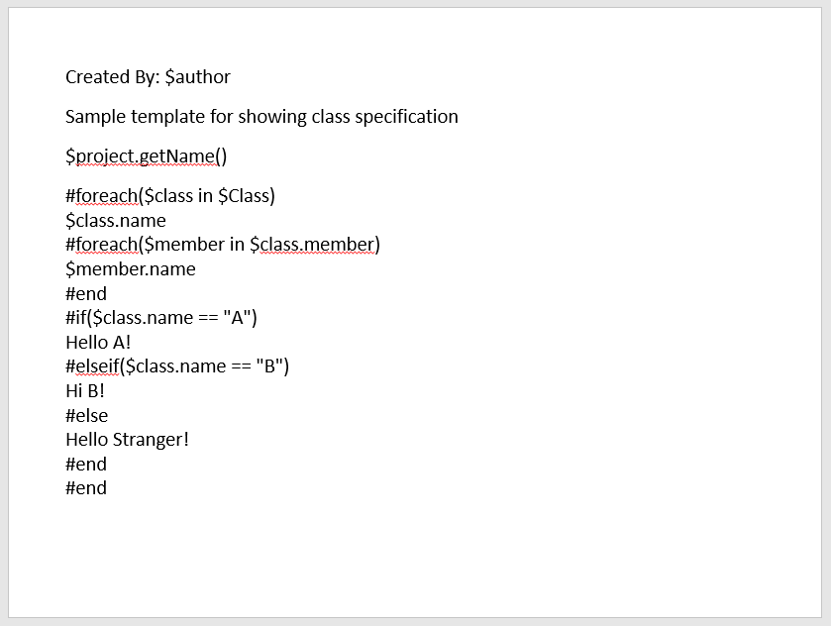

Page 2:



